# Installation of Inmeta.Exception.Reporter.Web.Site

Installation of the Inmeta Exception Reporter web site, see green frame in the diagram.

This document relates to the installation of this component component

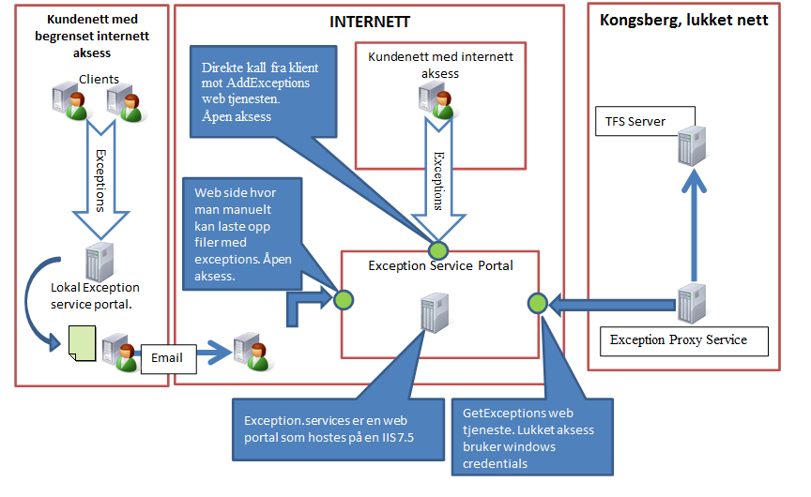

Installation steps:

1. Locate and start the file: “Inmeta.Exception.Reporter.Web.msi”
2. Click Next in this dialog:

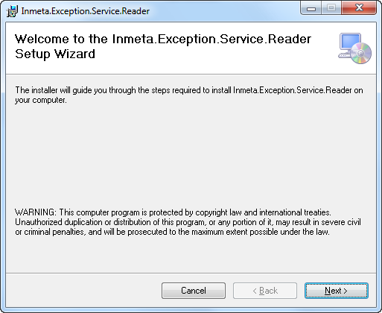

1. Keep settings ‘as is’ and click next.

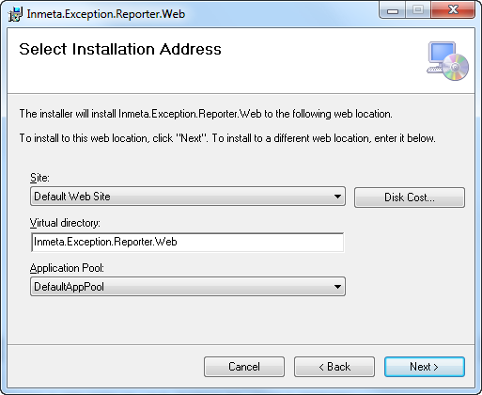

1. Click next and after installation completed click close.
2. Give ‘full control’ access to ASP.NET user to: %PROGRAMDATA%/inmeta/

If folder do not exists create it.

Granting access rights to the resource to the ASP.NET request identity: ASP.NET has a base process identity (typically {MACHINE}\ASPNET on IIS 5 or Network Service on IIS 6 and IIS 7, and the configured application pool identity on IIS 7.5).

To grant ASP.NET access to a file, right-click the file in Explorer, choose "Properties" and select the Security tab. Click "Add" to add the appropriate user or group. Highlight the ASP.NET account, and check the boxes for the desired access.